Mole to mole conversions
Molar Map:

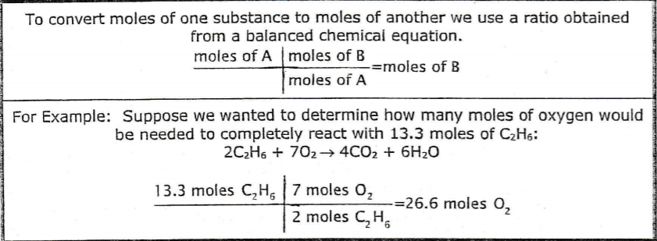

2 C₂H₆ + 7 O₂ 4 CO₂ + 6 H₂O

- What is the mole ratio between C₂H₆ and H₂O? __________________

- How many moles of water (H₂O) are produced from 20.3 moles of C₂H₆?

C + 2 H₂ CH₄

- What is the mole ratio between H₂ and CH₄? _________________

- How many moles of H₂ are required to produce 10 moles of methane, CH₄?

2 HNO₃ + Mg(OH)₂ Mg(NO₃)₂ + 2 H₂O

- What is the mole ratio between HNO₃ and H₂O? _____________

- How many moles of H₂O are produced from 8.21 moles of HNO₃?

CH₄ + 2 O₂ CO₂ + 2 H₂O

- How many moles of H₂O are produced from combustion of 12.5 moles of CH₄?

Cl₂ + 2 KBr 2 KCl + Br₂

- How many moles of KCl are produced from 4.3 moles of Cl₂?

